
Land Information Ontario (LIO) Warehouse
Data Class Name: Spot Height
Documentation
Produced by: Information Access and Information Management Policy Unit
Ministry of Natural Resources and Forestry
Date: July 27, 2015

Purpose

This document provides additional information to support the use of geospatial data. The Physical Model Diagram provides a visual representation of the relationships in the data class. The Data Change History lists all the modelling and access changes that have occurred during the lifecycle of the data class. A data description identifying table and field names is available upon request.

Need Assistance?
Please contact LIO Support at lio@ontario.ca or 705-755-1878 if you require help.

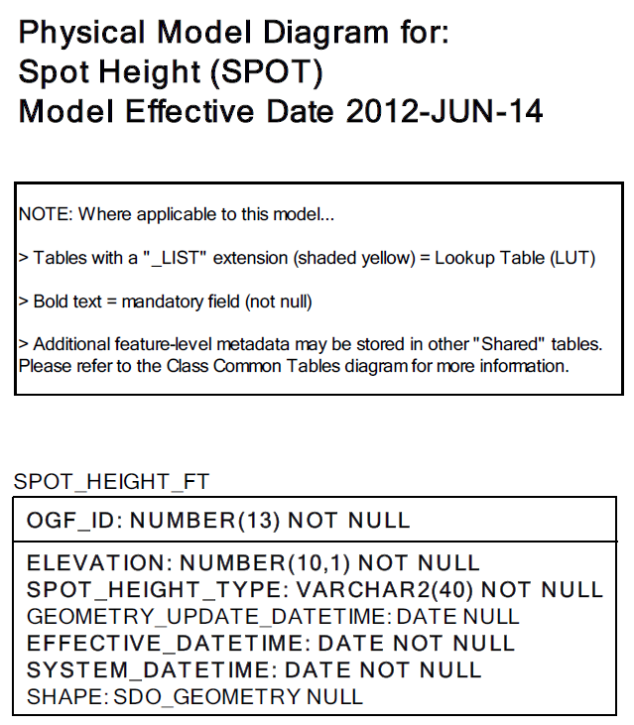
Data Class Change History

Data Class Name: Spot Height
Data Class Short Name: SPOT
Date  YYYY-MM-DD | Details of Change
2010 | Converted to SIMPLE Data Class - Table dropped: GEOGRAPHIC_UNIT  The Geographic Unit Type Number (GUT) and Source FMF Object ID have been added to the Spot Height table.
2008 | Data Class Description Change:  Received new description from BDI
2006-06 | Columns dropped: obm_spot and obm_map_sheet
2002-06 | Converted to structured data class with the folowing tables added:  - GEOG_UNIT  - JUSTIFICATION  - EXTERNAL_REFERENCE
2002-06 | New master table added: SPOT_HEIGHT
2002-06 | Data Class Short Name changed to SPOTHT
1999 | NEW Data Class
Data Description
Please refer to the metadata record for the data description.

